WT588D Chipset dimension

1、WT588D-18P package Dimension
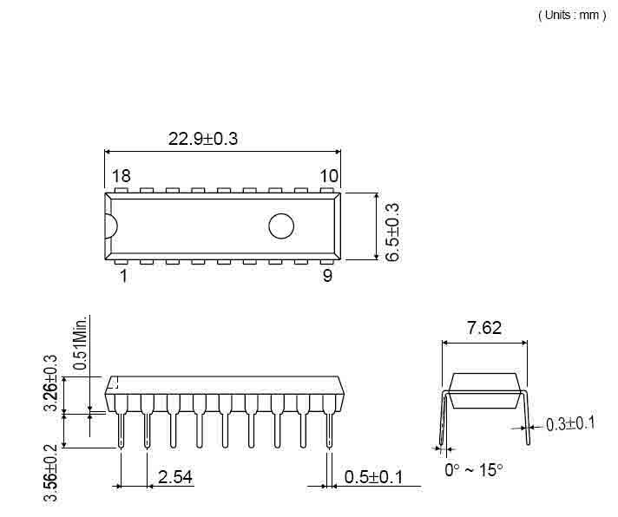

2、WT588D-20SS package Dimension
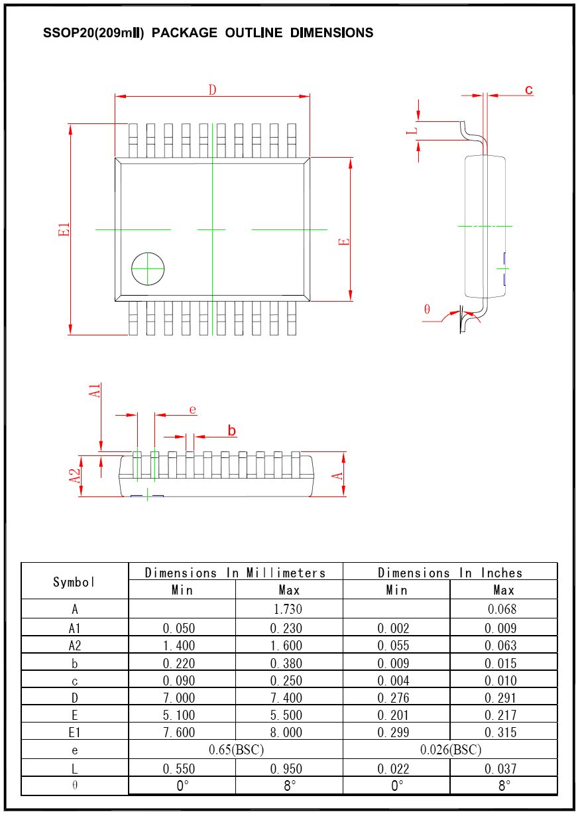

3、WT588D-32L package Dimension

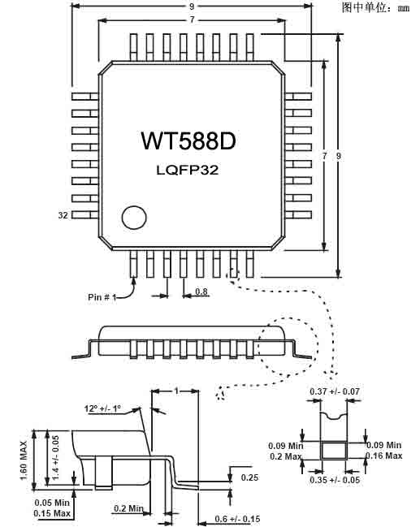

4、SPI-Flash package Dimension
4.1、25P20\25P40 package Dimension

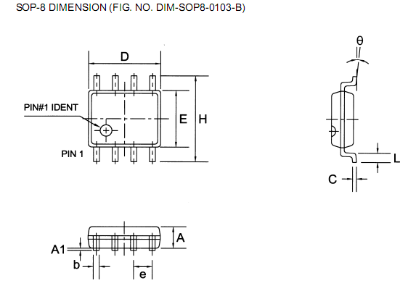
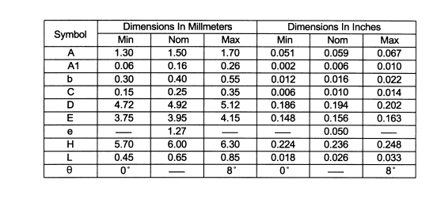

4.2、25P40\25P80\25P16\25P32 package Dimension
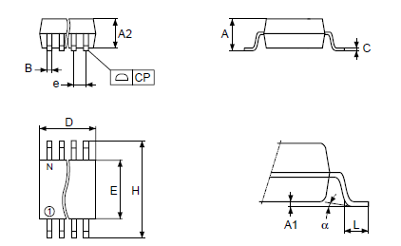
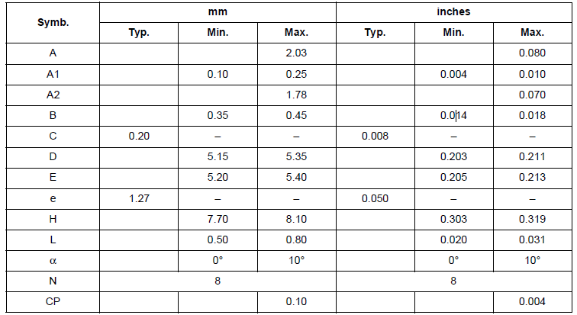

5、Dimension of WT588Dmodule
5.1、WTW-16P package Dimension
Unit：mm
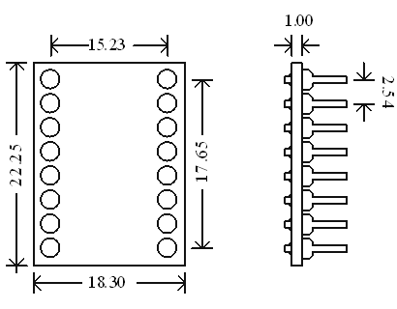

5.2、WTW-28P package Dimension
unit：mm
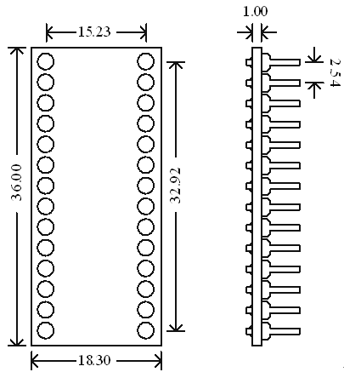
6、WTU02 package Dimension
6.1、WTU02-18P package Dimension

6.2、WTU02-20SS package Dimension

6.3、WTU02-32L package Dimension

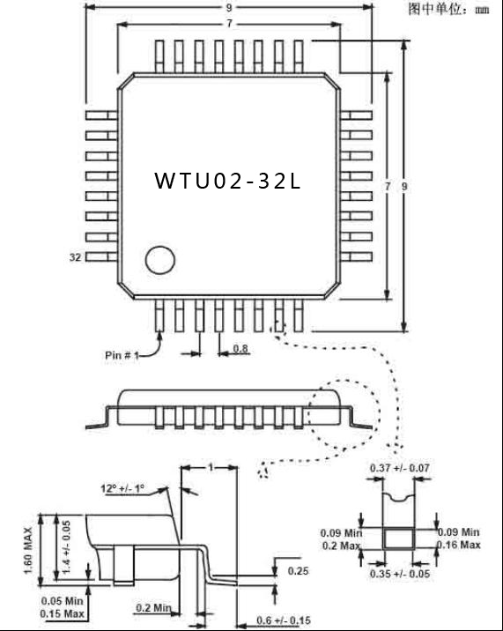

7、Function of SPI-Flash ‘ pins
SPI-Flash

Operating voltage of SPI-Flash： DC2.8V～3.5V， Therefore , please connect pin 3 , pin7 , pin 8 with positive power supply .
The relationship of SPI-Flash’s model & memory as follows:
Model | Memory | Model | Memory
25P20 | 2M | 25P16 | 16M
25P40 | 4M | 25P32 | 32M
25P80 | 8M | 25P64 | 64M

